<https://wintelguy.com/ip-mask-visualizer.pl>

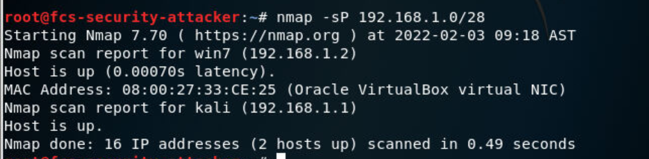

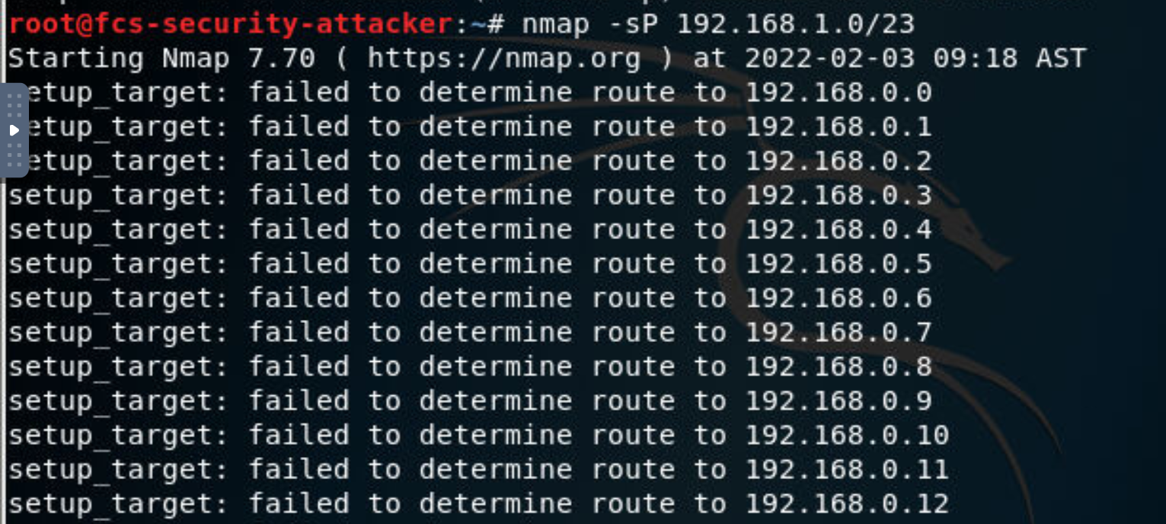

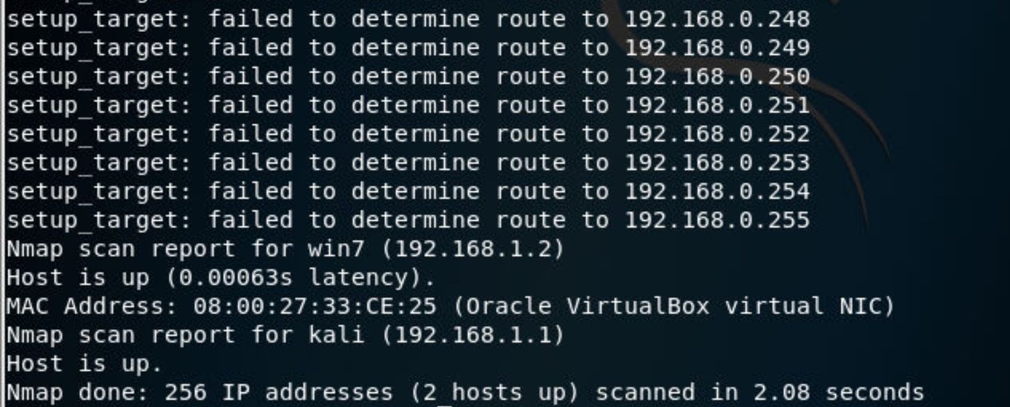

To find 64 host:

<https://wintelguy.com/ip-mask-visualizer.pl>

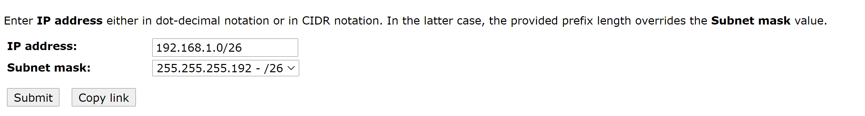

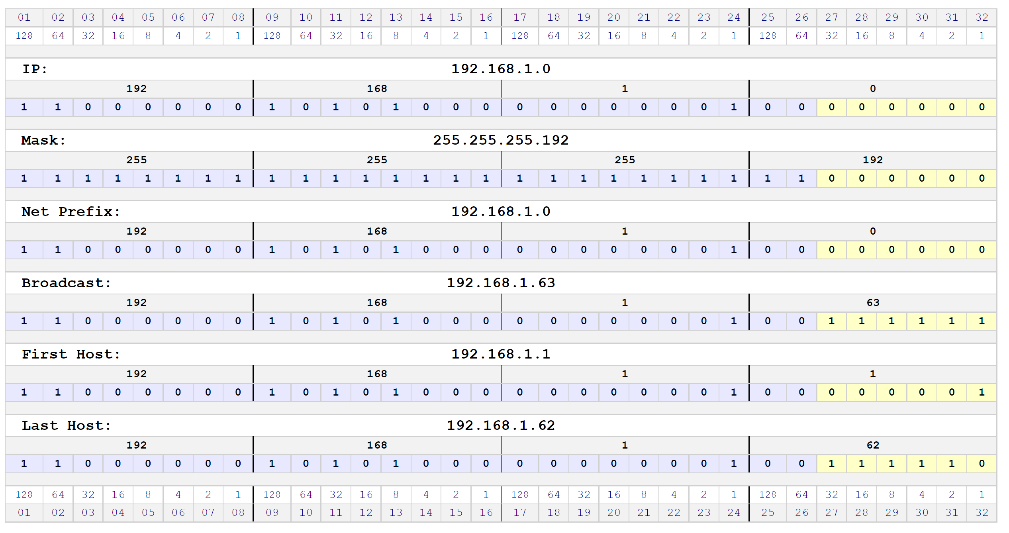

Victim Windows IP

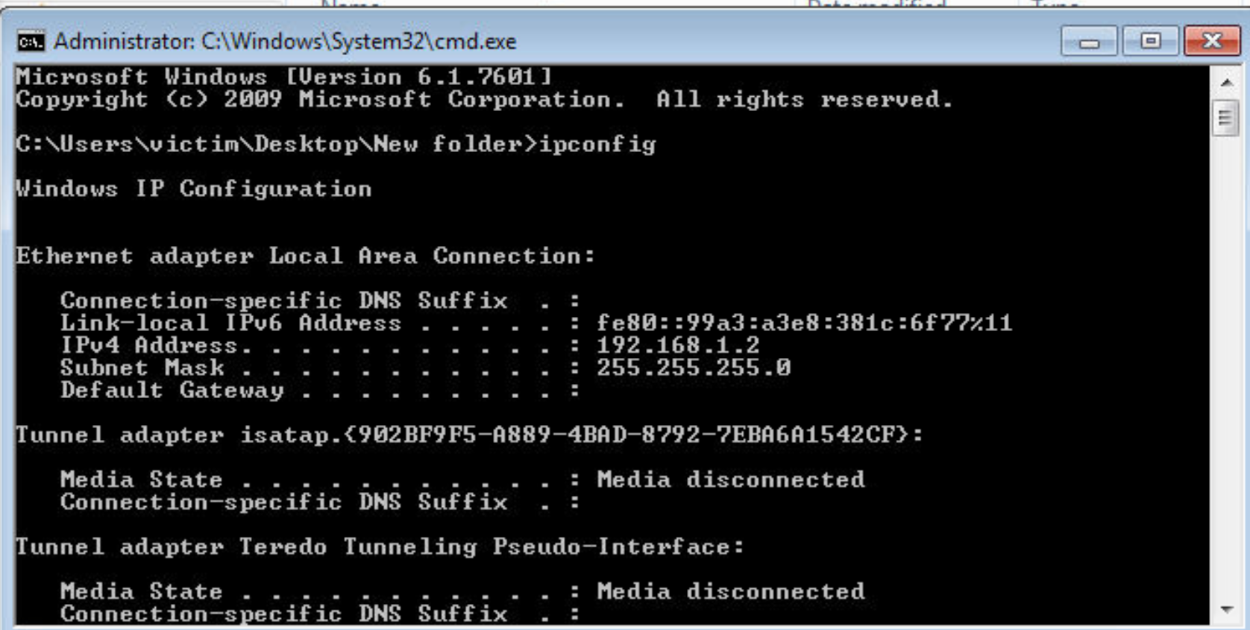

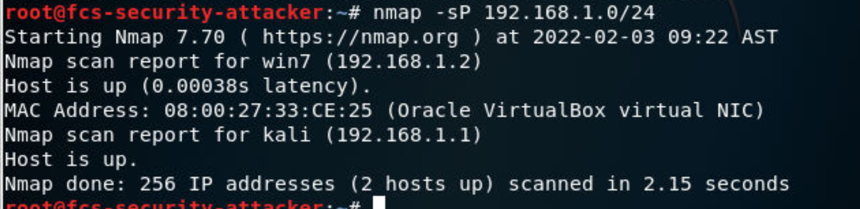

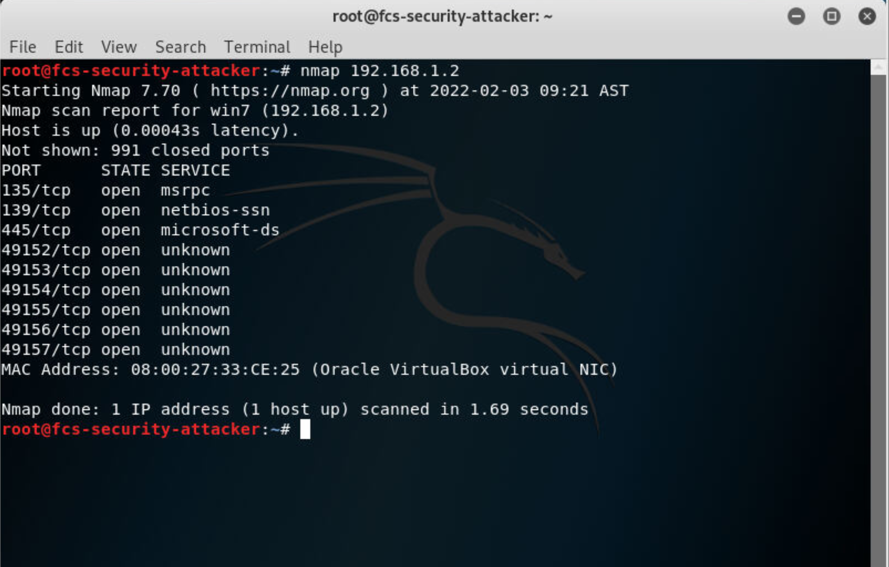

First Up Machine is Windows 192.168.1.2

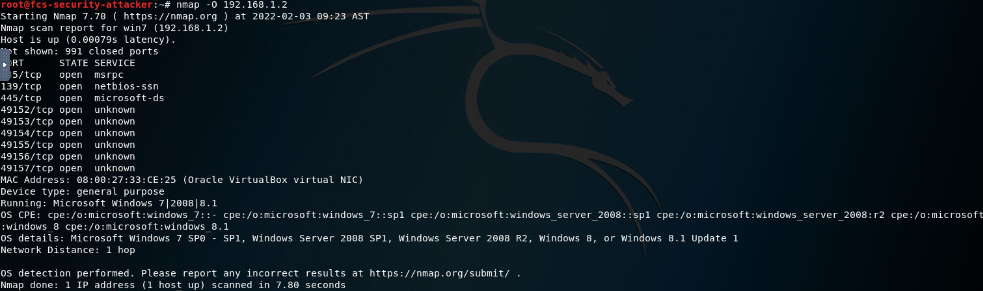

Open and reason

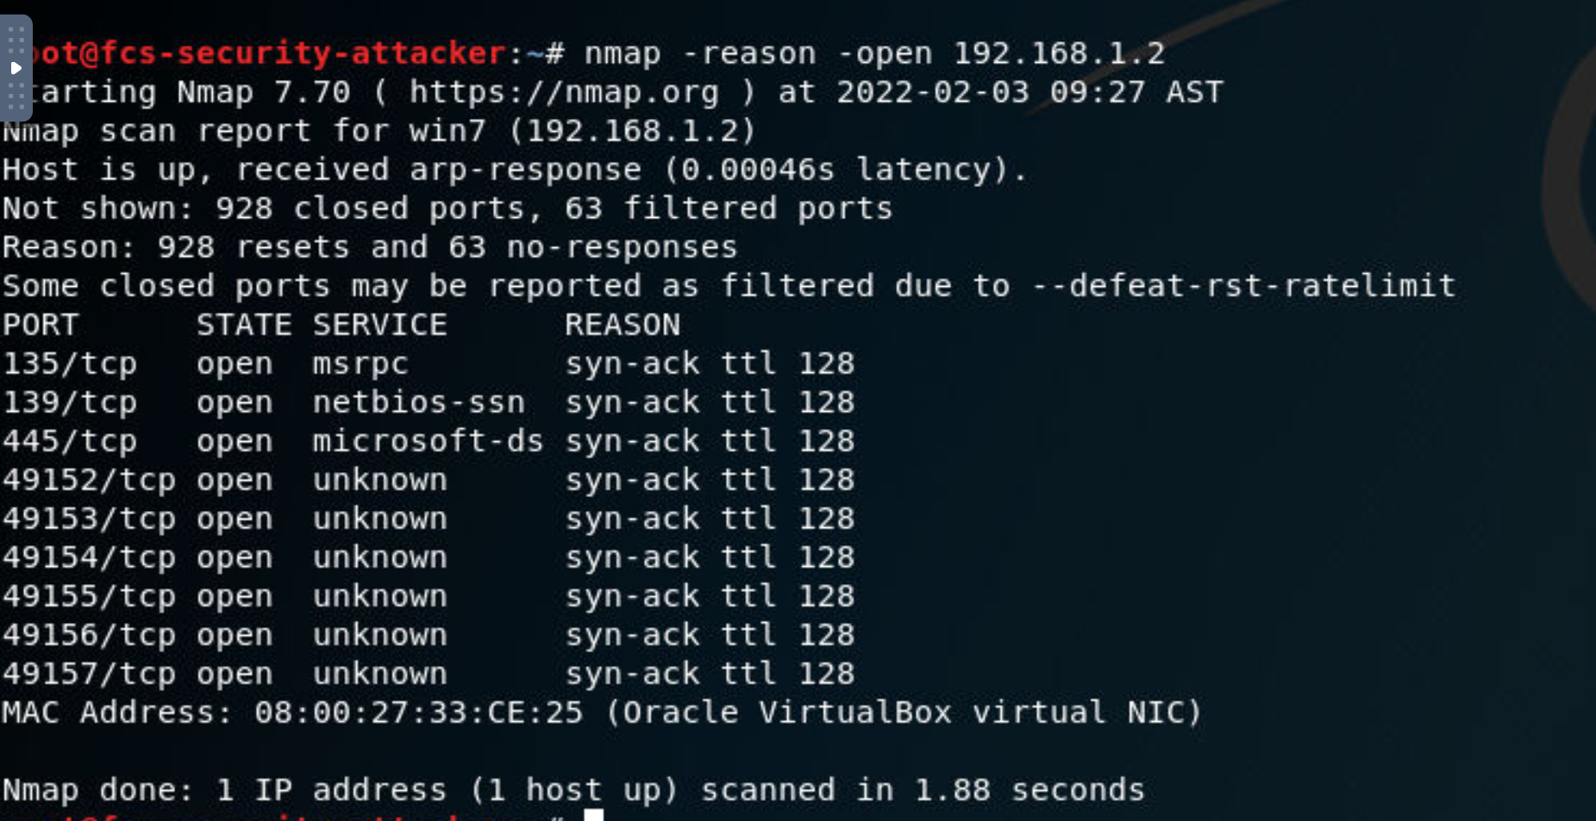

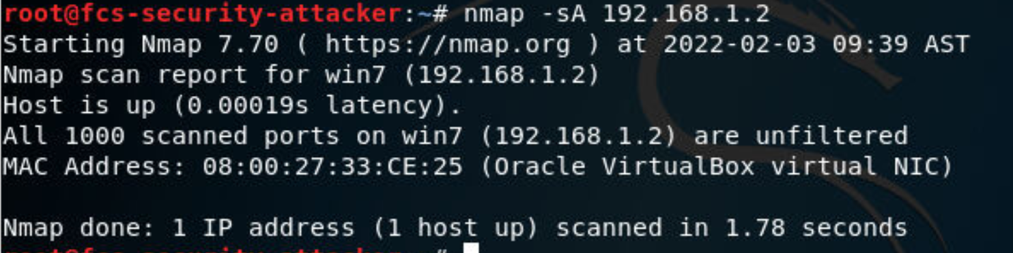

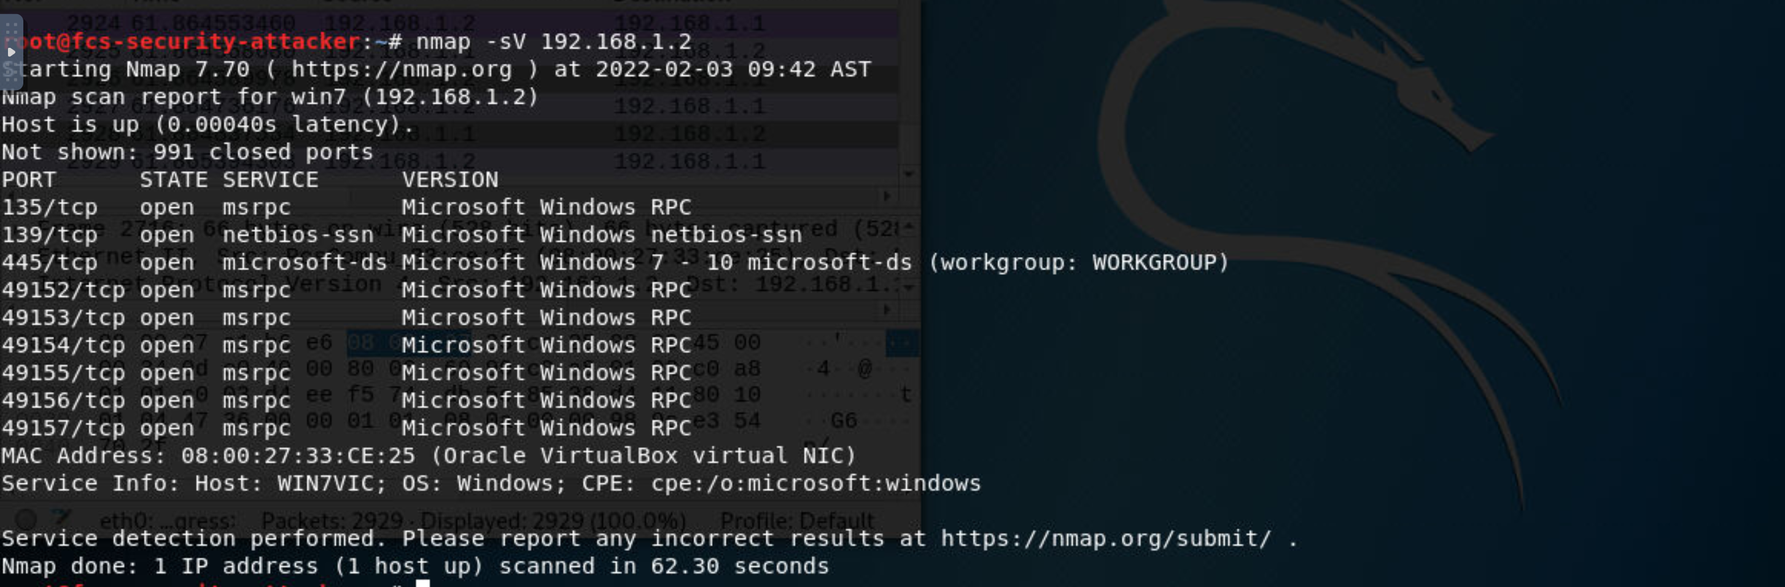

Captured Packets Available